**Drone**

**5.2 Data Analysis:**

The given table shows us the safe level concintration for a good quality of air. Our motive was taking data from different place and comparing the value of data. So we took data from two place Uttara and Bohundhara with the gps controlled drone.

|  |  |
| --- | --- |
|  |  |
| Pollutants | **Safe Level Concentration** |
| Carbon monoxide (CO) | **50ppm** |
| Nitrogen oxide(NOx) | **350ppm** |
| Sulphur dioxide (SO2) | **5ppm** |
| Particulate Matter (PM2.5) | **0.489ppm** |
| Particulate Matter (PM10) | **0.244ppm** |
| Ozone (O3) | **0.1ppm** |

**Data taken From Uttara:**

|  |  |  |  |  |  |  |  |
| --- | --- | --- | --- | --- | --- | --- | --- |
|  |  |  |  |  |  |  |  |
| **CO** | **converted CO** | **LPG Raw** | **LPG converted** | **Dust Raw** | **Dust Conv.** | **NOx Raw** | **NOx converted** |
| 101.72 | **88.79** | **309.877551** | **309.877552** | 151.18 | **46.82** | 149.9130435 | **79.66** |
| 102.40816 | **89.39** | 294.175 | **472.35** | 152.1 | **47.1** | 150.6 | **80.03** |
| 108.58 | **94.78** | 295.84 | **448.42** | 158.64 | **49.13** | 149.98 | **79.7** |
| 107.85 | **94.14** | 300.88 | **450.95** | 152.36 | **47.18** | 150.88 | **80.18** |
| 106.86 | **93.28** | 301.42105 | **458.64** | 152.0612245 | **47.09** | 157.2 | **83.54** |
| 106.6 | **93.05** | 1 | **459.46** | 153.36 | **47.18** | 151.1 | **80.3** |
| 107.05128 | **93.45** | 1 | **1.52** | 163.7755102 | **50.72** | 150.8367347 | **80.16** |
| 1 | **0.87** | 1 | **1.52** | 160.825 | **49.8** | 152.06 | **80.24** |
| 1 | **0.87** | 1 | **1.52** | 162.12 | **50.21** | 162.3469388 | **86.27** |
| 1 | **0.87** | 1 | **1.52** | 162.16 | **50.22** | 159.35 | **84.68** |
| 1 | **0.87** | 300.66667 | **1.52** | 162.5 | **50.32** | 161.06 | **85.59** |
| 1 | **0.87** | 479.28205 | **458.31** | 1 | **0.31** | 161.18 | **85.65** |
| 86.666667 | **75.65** | 509.16216 | **730.58** | 1 | **0.31** | 161.3947368 | **85.77** |
| 286.79487 | **250.34** | 510.06667 | **776.12** | 1 | **0.31** | 0.857142857 | **0.46** |
| 333.83784 | **291.41** | 504 | **777.5** | 1 | **0.31** | 1 | **0.53** |
| 329.33333 | **287.48** | 472.13333 | **768.25** | 1 | **0.31** | 1 | **0.53** |
| 228.33333 | **199.31** | 414.38095 | **719.68** | 137.6666667 | **42.63** | 0.979166667 |  |
| 302.42222 | **263.99** | 359.33333 | **631.65** | 289.7179487 | **89.72** | 1 | **0.53** |
| 272.19048 | **237.6** | 362.7619 | **547.74** | 361.972973 | **112.1** | 136.3333333 | **72.45** |
| 173.33333 | **151.3** | 361.5 | **552.96** | 360.6428571 | **111.69** | 287.3076923 | **152.68** |
| 234.45455 | **204.66** | 346.62 | **551.04** | 238.5 | **73.86** | 357.2972973 | **189.87** |
| 173.75 | **151.67** | 328.37931 | **528.36** | 316.7333333 | **98.09** | 356.1333333 | **189.25** |
| 234.38 | **204.59** | 293.38298 | **500.55** | 297.4285714 | **92.11** | 237 | **125.94** |
| 221.48276 | **193.33** | 296.64 | **447.21** | 179 | **55.43** | 313.0222222 | **166.34** |
| 102.75 | **89.69** | 293.32 | **452.17** | 230.1428571 | **71.27** | 292.952381 | **155.68** |
| 103.1 | **90** | 295.14 | **447.72** | 178.25 | **55.2** | 176.5 | **93.79** |
| 100.98 | **88.15** | 307.58 | **449.89** | 233.34 | **72.26** | 227.2380952 | **120.76** |
| 101.65306 | **88.73** | 289.62 | **468.85** | 228.2068966 | **70.67** | 176.25 | **93.66** |
| 101.58 | **88.67** | 294.32 | **441.67** |  |  | 229.24 | **121.82** |

|  |  |  |  |
| --- | --- | --- | --- |
|  |  |  |  |
|  |  |  |  |
| Table: Taken Data From Uttara.  if we see these data, we can esily compare these data with the table(safe level) and it is exceeding the safe level concintration. |  |  |  |
|  |  |  |  |
|  |  |  |  |
|  |  |  |  |
|  |  |  |  |
|  |  |  |  |
| Fig: Air quality monitoring at Uttara. |  |  |  |
|  |  |  |  |
| Fig: Barchart of CO Data( Green colow stands for CO).    Fig: Barchart of Methane Gas/LPG(orange stands for Methane).    Fig: Barchart of Methane Gas/LPG(Magenta Pink stands for Methane). |  |  |  |
|  |  |  |  |
|  |  |  |  |
|  |  |  |  |
|  |  |  |  |
|  |  |  |  |
|  |  |  |  |
|  |  |  |  |
|  |  |  |  |
|  |  |  |  |

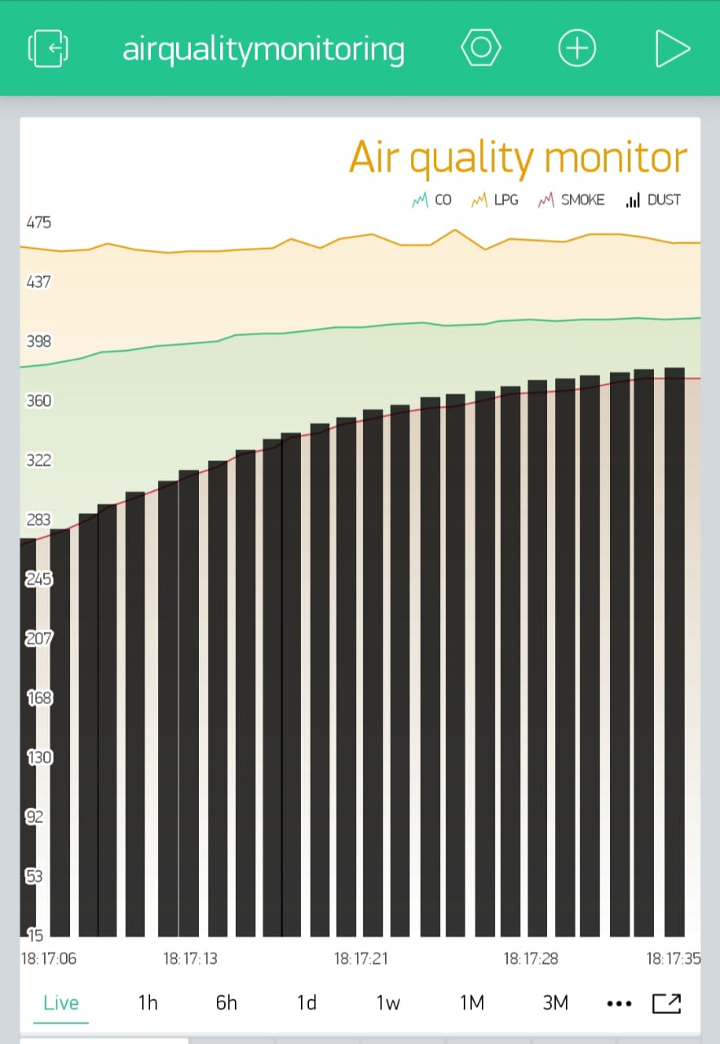

Fig: Barchart of Dust(Black stands for Methane).

From the data from uttara, we can see that the cocintration of each gases which were our projectparameters, CO, NOx, Methane, Dust these exceeds the safe level concintration.

we analysis the data using line graph and bar graph. These graph shows the live streaming data. Then we took snaps from our smart phone to record these data.We can clearly make a decison that the air quality of Dhaka is not that good,actually it is harmful,this is the reason why Dhaka paced first position in WORLD Ranking of AQI. this air day by day getting toxic hazards human health. incresing the rate of illness. there were also another options to design our project interface.We can add any button, slider and other designs as well in local blynk server.

**5.2 Discussion:**

We've done building our drone in EEE499A. Then we have completed the set up making using required components. It was the most complex part and an important part of our project. it was really difficult to function all the parts of the project together. As we have both hardware and software part in our project. we had drone, a components set up, and had to calibrate this with coding and software. wehad to look after evrey parts at a same time, had to cotrolled everything together. we had checked over and over if the nodemcu sends its data to the server properly or not,then we had to connect all the system in a same wifi line, otherwise the NodeMCU can not properly sends its data to the server. also there were actually so many steps that we have followed for getting data with properly flying Drone. In drone, Per motor draws 2A while hovering. So, 4 motor draws 8A for hovering in the air. Our selected battery is 2.2Ampere/hour. That means it can delivery 2.2A for 1 hour (60minutes).

Approximately we got 10/12 mins for flying drone, in these short period of time we have maneged for taking data. Flight time decreses because of connecting set up with the same lipo battery. Having all these difficulties,finally we have achied our goals successfully what we designed and planned to complete our project. Besides,

Limitations:

1. If hardware cannot perform well then takin data will be a great problem for this project.

**Financial perspective – cost effectiveness**

Our air quality monitoring drone is a low budget, cost effective drone.

**Resource availability:**

Common quadcopter components are available in Dhaka, Bangladesh.

**Social importance:**

The major contributors to global warming, acidification of air, eutrophication and ozone layer depletion are the mining and electricity generating stations. Global warming is a major issue and such environmental drones are very important for the people residing in our country. The social importance of such projects that involve the monitoring and filtration of air pollution is humongous.

**Legal issues:**

Government permission is needed to make GPS equipped drones work. We need the permission of the government of our country to allow us to work using our drone for the statistical analyses of the data collected by our drone**.** Permission is required whether we navigate our drone in city or in forest or any such countryside areas. However even after getting the required government permission we are not allowed to navigate our drone in certain places of our country issued by our government:

* Any police station
* Army Residence:

Cantonment Area

DOHS Area

* Parliamentary Area
* Airport Region

**Ethical Impact**

The ethical issues about using our Drone can be split into four basic areas.

* Regulation
* Safety
* Privacy
* Noise

According to Federal Aviation Administration (FAA), the vertical distance and the place where drone will fly is fixed. In our country, government restricted some places for flying drone. Authority has taken decisions for flying drones in the country’s airspace. If anyone violate the rules of government i.e. unethical behavior like spying, or causing discomfort for other people, or making trouble, then this drone can be used for unethical issues. Besides our drone will fly from a low altitude, if safety precaution is not taken then anyone can be injured for personal purpose which is also an unethical misconduct. Drones can be easily used for taking geographical data, so special safeguard is needed for not violating privacy & for safety purposes. All these situations are depending on the users.

**Economic Impact**

The economic impact of our project is much effective. Total cost of our project is less than 30k which is economically friendly with some unique features. Comparatively our air quality monitoring project is standard and budget friendly than others one available in the market. It is very easy to use and control for the user. This is something the most standard and affordable one which can offer the most wanted feature and applicable for Dhaka city for detecting pollutants density. We made this project really happened thinking of specially developing like our country, as most of the development and under development country cannot afford this unique aircraft for economic issues. So not only for us, this project must be a blessing for those underdevelopment countries to save the nature.

**Environmental Impact**

In the perspective of environmental issue, our project is eco-friendly. As it will not emit any gases to the nature. Besides it helps to detect the pollutants, we made this project thinking about nature too, as day by day our nature is getting dusty and increases its rate of pollutants. So, this drone will play an important role saving our environment. Seeing data from the sensors, we can take proper steps for most polluted cities. On the other hand, this drone will run with a rechargeable battery, will not produce any CO2. We have tried ours project keeping available for government and general people.

**5.3 Future Work** **(EEE499B):**

We have finished all our work during EEE499b. Our plan for the project in future covers:

* **Adding various application**
* **Advance analyzing using Machine Learning and image processing**
* **Controlling Our Drone with mind signal (Mind control Drone)**
* Making this drone more robust